**Compile VPP with DPDK**

1. Install OFED

# mount -o loop MLNX_OFED_LINUX-4.4-2.0.7.0-rhel7.5alternate-aarch64.iso /mnt/

# cd /mnt && ./mlnxofedinstall --add-kernel-support --dpdk --upstream-libs

1. Download VPP code

# git clone <https://gerrit.fd.io/r/vpp>

1. Compile and install DPDK development package

# make dpdk-install-dev DPDK_MLX5_PMD=y

One rpm package named vpp-ext-deps-19.04-0.aarch64.rpm will be build in build/external/. In order to find the network device by commls

and “vppctl show int”, we should install this rpm package. This rpm package will be installed automatically after running “make dpdk-install-dev DPDK_MLX5_PMD=y”.

1. Install the dependent tools

# make install-dep

One issue will be reported as below:



Resolve this issue above is delete the parameter “-E” in the Makefile file as below:

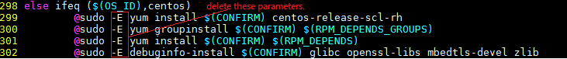

1. Compile vpp code.

# Make build (or make build-release)

1. Compile vpp code and build rpm packages.

# make pkg-rpm vpp_uses_dpdk_mlx5_pmd=yes

Then, the rpm packages will be found in directory build-root/:

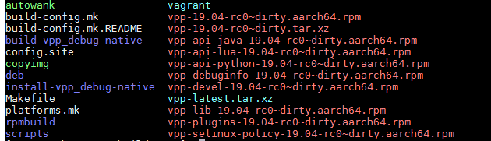

1. Install VPP rpm package

# cd build-root && rpm -ivh ./*.rpm

1. Config the VPP configuration (one example configuration file)



1. Start VPP service

# systemctl start vpp

1. Login in the VPP cli

# telnet localhost 5002

1. Show interface address



1. Make the network device up

vpp# set interface state FiftySixGigabitEthernet1/0/0 up

1. Config the network device’s ip and network device’s ip mask bit.

vpp# set interface ip address FiftySixGigabitEthernet1/0/0 10.0.0.1/24



1. Ping another host ip in vpp cli

vpp# ping 10.0.0.3

116 bytes from 10.0.0.3: icmp_seq=2 ttl=64 time=.0717 ms

116 bytes from 10.0.0.3: icmp_seq=3 ttl=64 time=.0264 ms

116 bytes from 10.0.0.3: icmp_seq=4 ttl=64 time=.0231 ms

116 bytes from 10.0.0.3: icmp_seq=5 ttl=64 time=.0227 ms

We have run the vpp successfully now!

groupadd vpp

mkdir –p /var/log/vpp

/root/vpp/build-root/build-vpp-native/external/dpdk-18.11/drivers/net/mlx5/mlx5_flow_tcf.c:8:10: fatal error: libmnl/libmnl.h: No such file or directory

#include <libmnl/libmnl.h>

net_mlx5: cannot load glue library: librte_pmd_mlx5_glue.so.18.11.0: cannot open shared object file: No such file or directory

net_mlx5: cannot initialize PMD due to missing run-time dependency on rdma-core libraries (libibverbs, libmlx5)

wget http://content.mellanox.com/ofed/MLNX_OFED-4.5-1.0.1.0/MLNX_OFED_LINUX-4.5-1.0.1.0-rhel7.5alternate-aarch64.tgz

tar -zxvf MLNX_OFED_LINUX-4.5-1.0.1.0-rhel7.5alternate-aarch64.tgz

cd MLNX_OFED_LINUX-4.5-1.0.1.0-rhel7.5alternate-aarch64

./mlnxofedinstall --dpdk --upstream-libs --add-kernel-support